

Tech Saksham

*Capstone Project Report*

# ARTIFICIAL INTELLIGENCE AND MACHINE LEARNING FUNDAMENTALS

***“HEART DISEASE PREDICTION ”***

***“ANNA UNIVERSITY REGIONAL CAMPUS TIRUNELVELI”***

|  |  |
| --- | --- |
| ***NM ID*** | ***NAME*** |
| *au950021135014* | *B.DIVYASREE* |

*Trainer Name :* ***RAMAR***

ABSTRACT

*This project focuses on employing logistic regression, supported by AI and ML techniques, for heart disease prediction—a critical aspect in reducing cardiovascular disease (CVD) mortality rates. With the World Health Organization's alarming estimate attributing four out of five CVD deaths to heart attacks, timely identification of individuals at risk becomes imperative. By leveraging patient data, including demographic, medical, and lifestyle factors, this study aims to pinpoint the ratio of patients predisposed to CVD and predict overall risk. The proposed logistic regression model serves as a tool for healthcare professionals, facilitating early intervention strategies and ultimately contributing to the mitigation of CVD's global burden*

INDEX

|  |  |  |
| --- | --- | --- |
| ***Sr. No.*** | ***Table of Contents*** | ***Page No.*** |
| *1* | *Chapter 1: Introduction* | *4* |
| *2* | ***Problem Statement*** | *5* |
| *4* | *Conclusion* | *6* |
| *7* | *Code* | *7* |

CHAPTER 1 INTRODUCTION

Cardiovascular diseases (CVDs) are a leading cause of mortality worldwide, with heart attacks accounting for a significant portion of these deaths. The World Health Organization (WHO) estimates that four out of five CVD deaths are due to heart attacks, highlighting the critical need for effective prediction and prevention strategies. In this research, we aim to develop a predictive model using logistic regression to identify individuals at risk of CVD and estimate their overall risk.

CHAPTER 2

Problem statement

***Heart disease remains a leading cause of mortality worldwide, with cardiovascular diseases (CVD) contributing significantly to this burden. Timely identification of individuals at risk of heart disease is crucial for effective intervention and prevention strategies.***

***This project aims to develop a logistic regression model to predict the likelihood of heart disease occurrence based on various risk factors. By leveraging logistic regression, we seek to provide healthcare professionals with a reliable tool for early detection and intervention, ultimately reducing the morbidity and mortality associated with cardiovascular diseases.***

CONCLUSION

* *Our project represents a significant advancement in real-time emotional recognition.*
* *By considering both facial emotions and age, the system enhances human-computer interaction.*
* *Leveraging cutting-edge AI/ML techniques and innovative system design, our goal is to create a versatile and efficient system for personalized user experiences across various domains and applications*

*CODE*

*Dependency:*

*import numpy as np import pandas as pd import matplotlib.pyplot as plt import seaborn as sns from sklearn.model_selection import train_test_split from sklearn.linear_model import LogisticRegression from sklearn.metrics import accuracy_score*

# DATA COLLECTION AND PROCESSING :

*#import csv data to pandas dataframe data=pd.read_csv("/content/heart.csv")*

*print(data)*

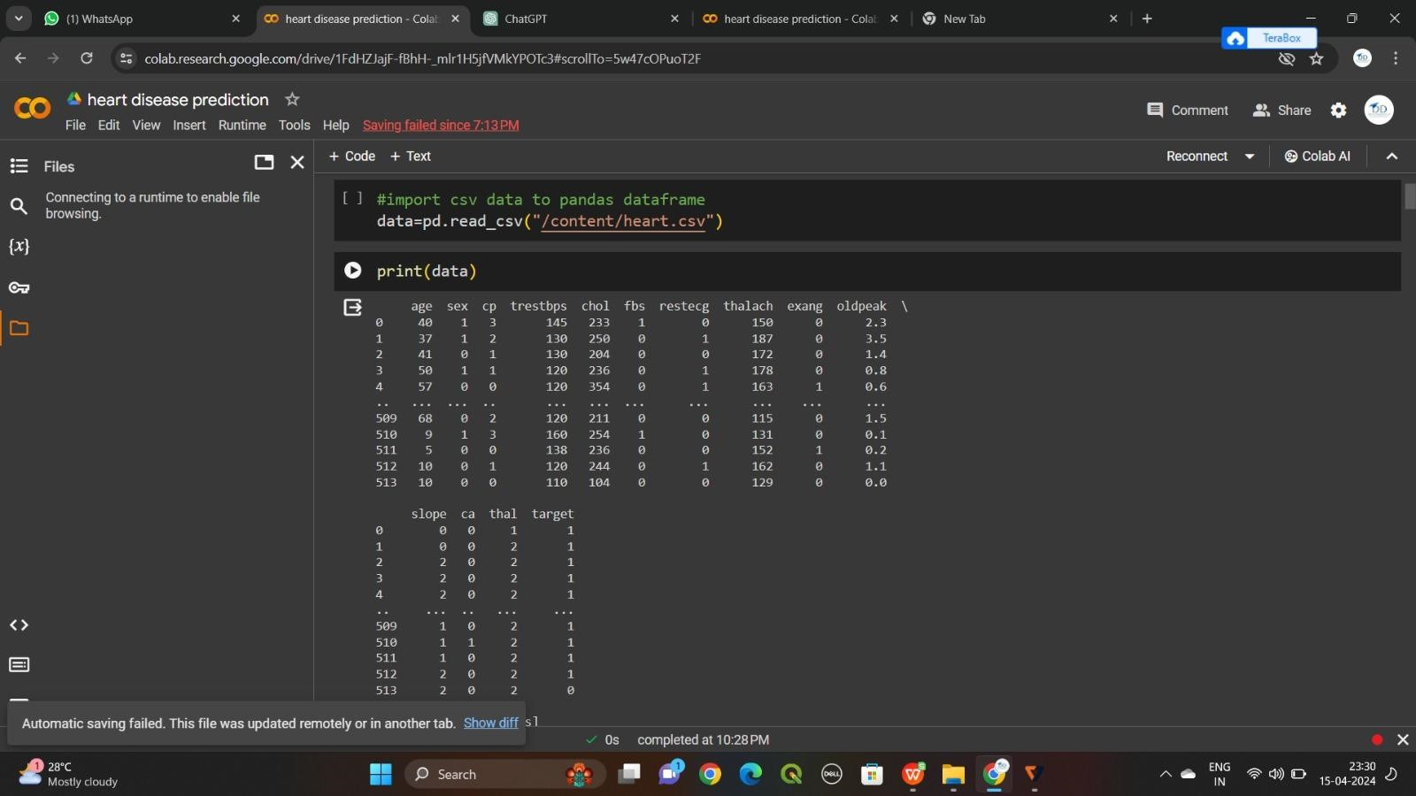

# STEP 1 EDA

*# Split the dataset into features and*

*labels X = data.drop('sex',axis=1) y = data['sex']*

*# Split data into training and testing sets*

*X_train, X_test, y_train, y_test = train_test_split(X, y, test_size=0.2, random_state=42)*

*# Initialize the logistic regression model model = LogisticRegression()*

*# Train the model model.fit(X_train, y_train)*

*# Predict gender for new data*

*# Assuming you have a new dataset 'new_data' with features # new_predictions = model.predict(new_data)*

*# Count the number of males and females in the 'gender' column male_count = (data['sex'] == 1).sum() female_count = (data['sex']*

*== 0).sum()*

*print("Male count:", male_count) print("Female count:", female_count)*

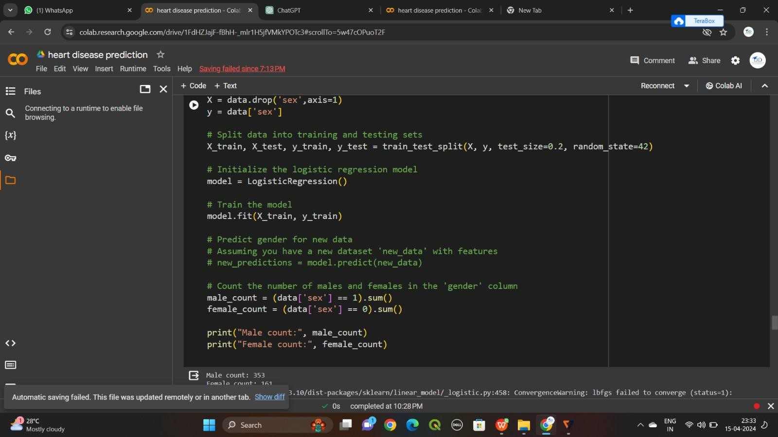

*Male count: 353*

*Female count: 161*

# AFFECTEDS

*# Split data into features and target variable X = data[['sex']] y = data['target']*

*# Split data into training and testing sets*

*X_train, X_test, y_train, y_test = train_test_split(X, y, test_size=0.2, random_state=42)*

*# Create logistic regression model log_reg = LogisticRegression()*

*# Train the model log_reg.fit(X_train, y_train)*

*# Initialize the logistic regression model model = LogisticRegression()*

*# Train the model model.fit(X_train, y_train)*

*# Count the number of males and females in the 'gender' column male_count = (data['sex'] == 1).sum() female_count*

*= (data['sex'] == 0).sum()*

*print("Male count:", male_count) print("Female count:", female_count)*

*# Predict probabilities probabilities = log_reg.predict_proba(X_test)[:,1]*

*# Classify individuals as having the disease if their predicted probability is above 0.5 predictions = (probabilities > 0).astype(int)*

*# Combine predictions with actual gender for analysis predictions_df = pd.DataFrame({'sex': X_test['sex'], 'prediction': predictions, 'actual': y_test})*

*# Count the number of males and females who are predicted to have the disease male_disease_count = predictions_df[(predictions_df['sex'] == 1) &*

*(predictions_df['prediction'] == 1)].shape[0] female_disease_count = predictions_df[(predictions_df['sex'] == 0) & (predictions_df['prediction'] == 1)].shape[0]*

*print("Number of males with heart disease:", male_disease_count) print("Number of females with heart disease:", female_disease_count)*

*# healthy male male=male_count- male_disease_count*

*#healthy female female=female_count- female_disease_count print( " Number of males without heart disease:" ,male) print( " Number of males without heart disease:",female)*

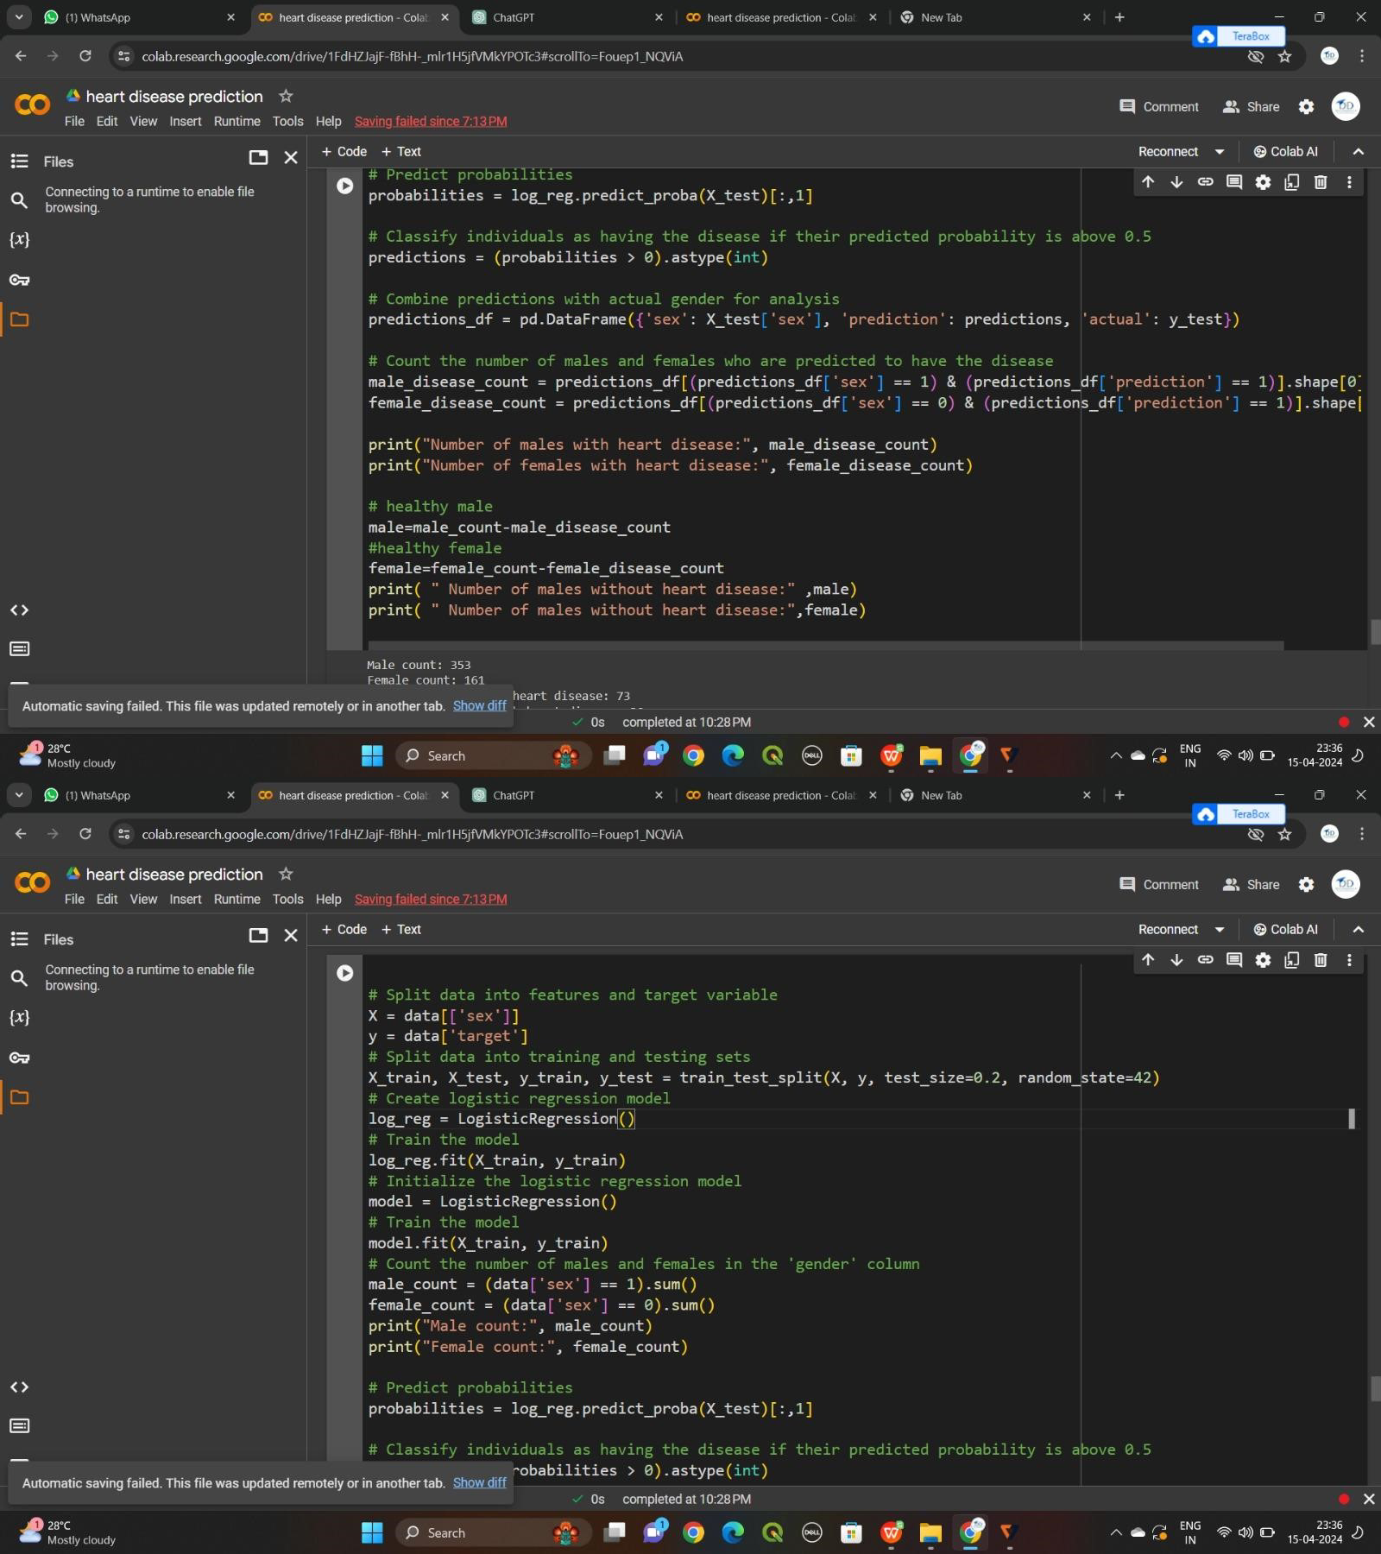

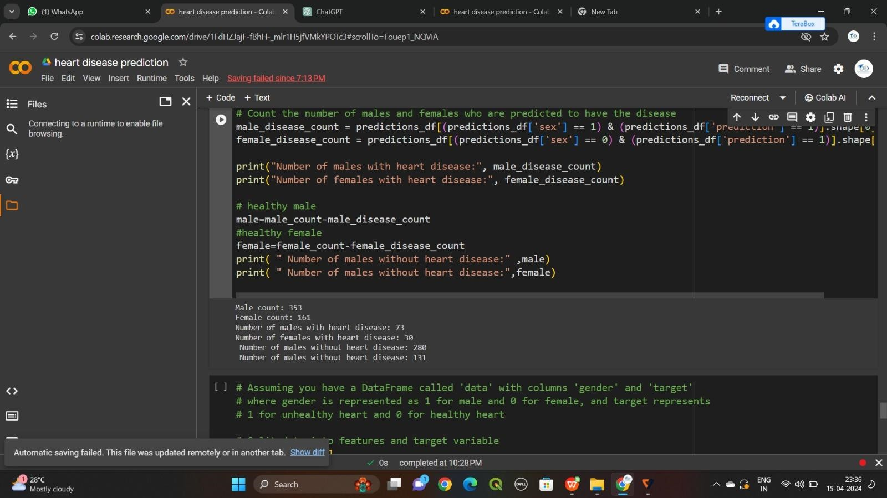

Creating the features and target x=data.drop(columns='target',axis=1) y=data['target'] # to print x print(x) age sex cp trestbps chol fbs restecg thalach exang oldpeak \

1 40 1 3 145 233 1 0 150 0 2.3

2 37 1 2 130 250 0 1 187 0 3.5

3 41 0 1 130 204 0 0 172 0 1.4

4 50 1 1 120 236 0 1 178 0 0.8 4 57

0 0 120 354 0 1 163 1 0.6

.. ... ... .. ... ... ... ... ... ... ...

509 68 0 2 120 211 0 0 115 0 1.5

510 9 1 3 160 254 1 0 131 0 0.1

511 5 0 0 138 236 0 0 152 1 0.2

512 10 0 1 120 244 0 1 162 0 1.1 513

10 0 0 110 104 0 0 129 0 0.0

slope ca thal 0 0 0 1

1 0 0 2

2 2 0 2

3 2 0 2

4 2 0 2

|  |  |  |  |  |  |  |
| --- | --- | --- | --- | --- | --- | --- |
| ***.. ... ..*** | ***...*** |  |  | | | |
| ***509 1*** | ***0*** | ***2*** |
| ***510 1*** | ***1*** | ***2*** |  |  |  |  |
| ***511 1*** | ***0*** | ***2*** |  |  |  |  |
| ***512 2*** | ***0*** | ***2*** | ***513*** | ***2*** | ***0*** | ***2*** |

[514 rows x 13 columns] # to print y print(y)

1 1

|  |  |  |
| --- | --- | --- |
| ***2*** | ***1*** |  |
| ***3*** | ***1*** |
| ***4*** | ***1*** |
| ***5*** | ***1*** | ***..*** |
| ***509*** | ***1*** |  |
| ***510*** | ***1*** |  |
| ***511*** | ***1*** |  |
| ***512*** | ***1*** |  |
| ***513*** | ***0*** |  |

Name: target, Length: 514, dtype: int64

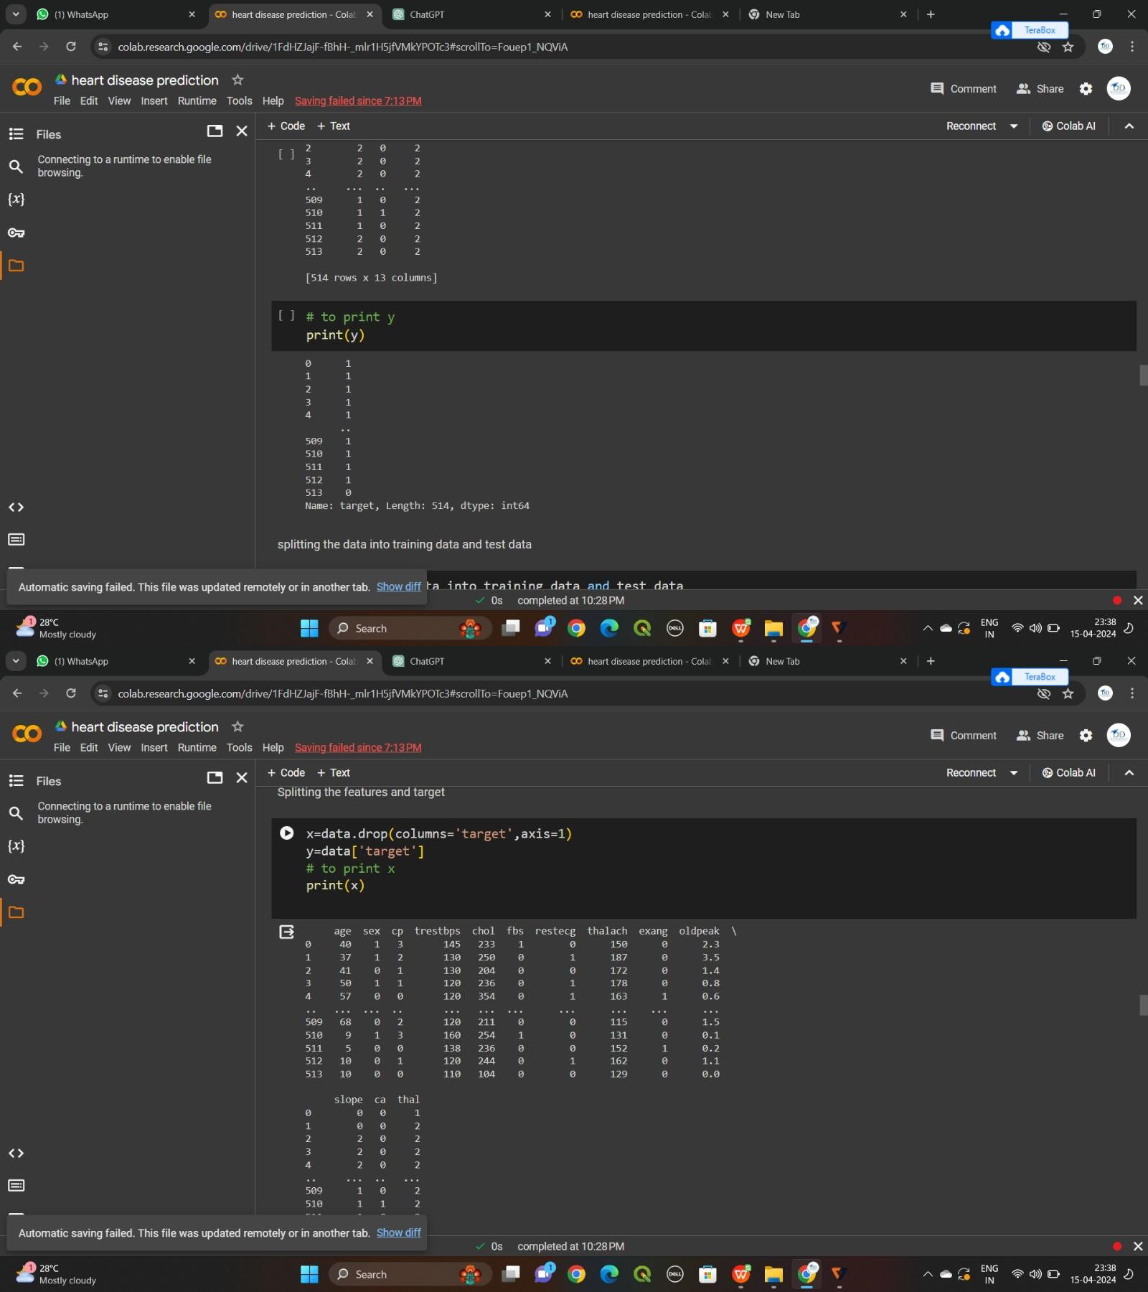

splitting the data into training data and test data x_train,x_test,y_train,y_test=train_test_split(x,y,test_size=0.2,st rat ify=y,random_state=42) print(x.shape,x_train.shape,x_test.shape) op

(514, 13) (411, 13) (103, 13)

Step 4

MOdel training

logistic regression model=LogisticRegression()

#training the logistic regression model with training data model.fit(x_train,y_train) op

/usr/local/lib/python3.10/distpackages/sklearn/linear_model/

_logistic.py:458:

ConvergenceWarning: lbfgs failed to converge (status=1): STOP: TOTAL NO. of ITERATIONS REACHED LIMIT.

Increase the number of iterations (max_iter) or scale the data as shown in:

https://scikit-learn.org/stable/modules/preprocessing.html

Please also refer to the documentation for alternative solver options:

https://scikitlearn.org/stable/modules/linear_model.html#logi stic-regression n_iter_i = _check_optimize_result(

LogisticRegression LogisticRegression()

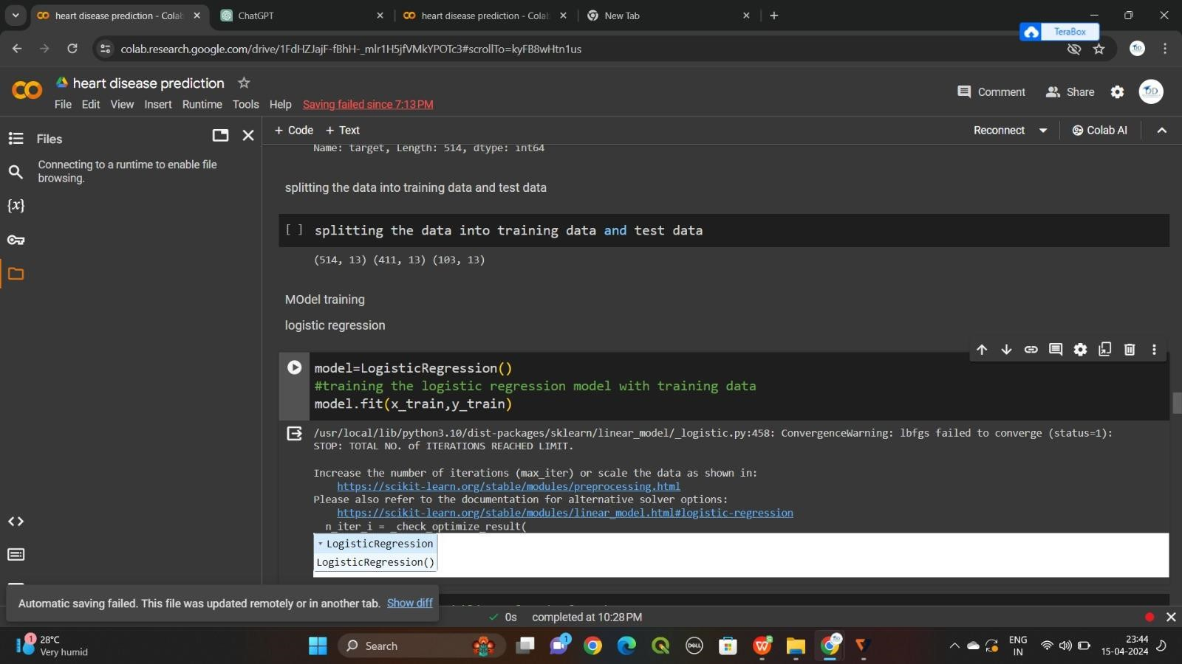

Create fuction for evaluating matrix #accuracy of training data x_train_prediction=model.predict(x_train)

training_data_accuracy=accuracy_score(x_train_prediction,y_tr

ai n) print('tarining data accuracy:',training_data_accuracy) tarining data accuracy: 0.8442822384428224

#accuracy of test data x_test_prediction=model.predict(x_test) test_data_accuracy=accuracy_score(x_test_prediction,y_t est) print('test data accuracy:',test_data_accuracy) st data accuracy:

0.8640776699029126

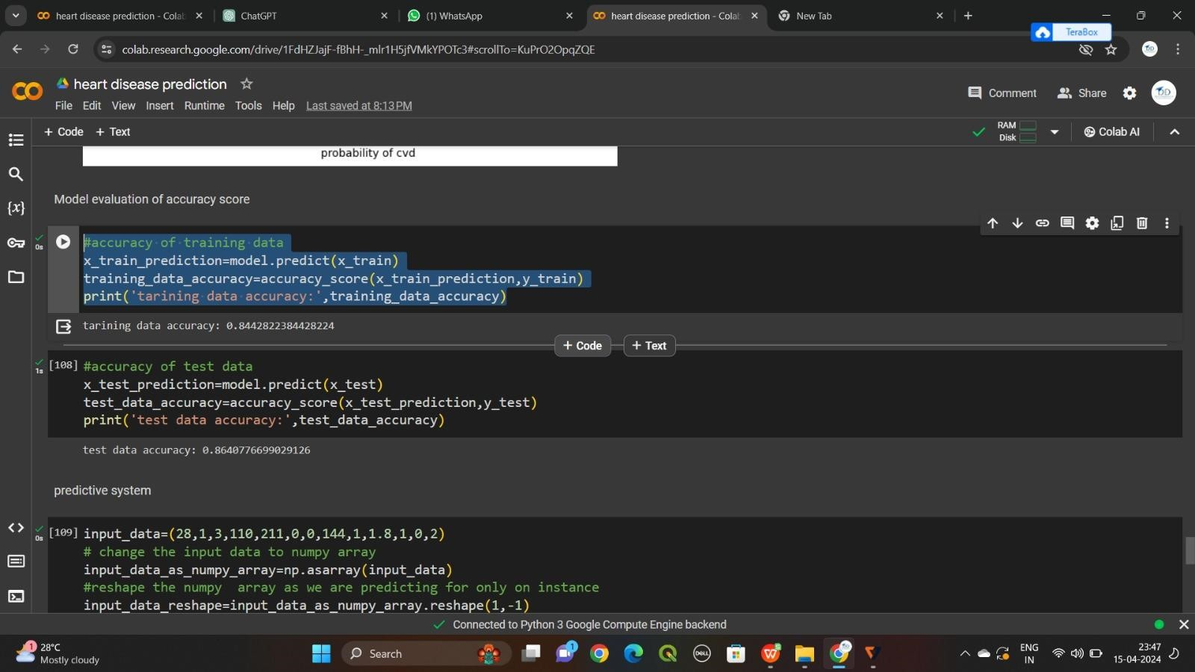

Looking at the evaluation metrics for our best model input_data=(28,1,3,110,211,0,0,144,1,1.8,1,0,2) #

change the input data to numpy array input_data_as_numpy_array=np.asarray(input_data) #reshape the numpy array as we are predicting for only on

instance input_data_reshape=input_data_as_numpy_array.reshape(1,-1) prediction=model.predict(input_data_reshape) print(prediction) if(prediction[0])==0:

print('the person does not have heart disease') else: print('the person has heart disease')

[1] the person has heart disease

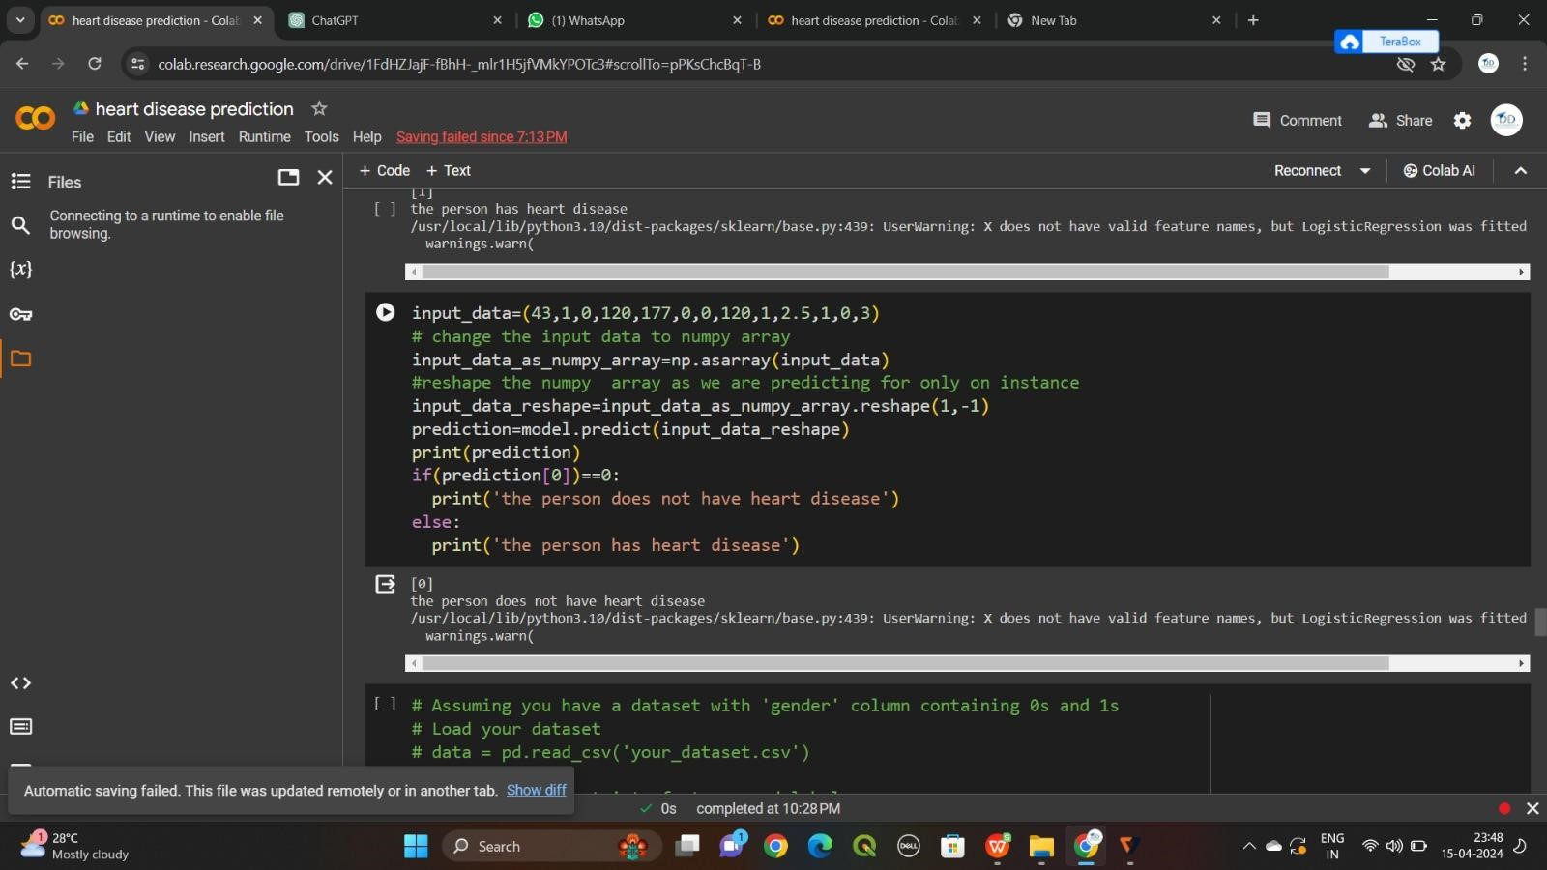

Lets save our model using pickle

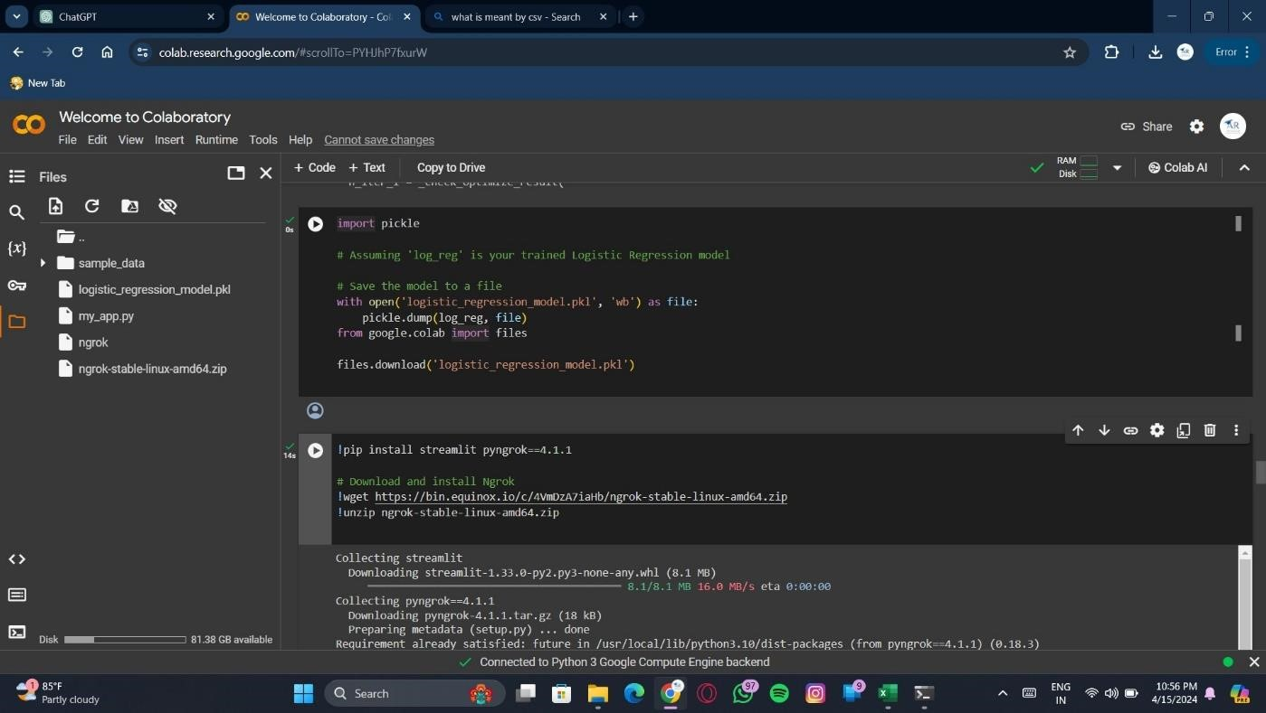

Import streamlit ,pyngrok,and ngrok modules

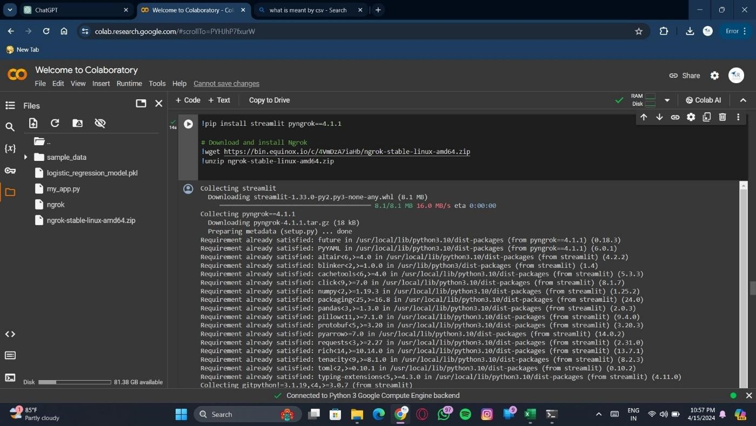

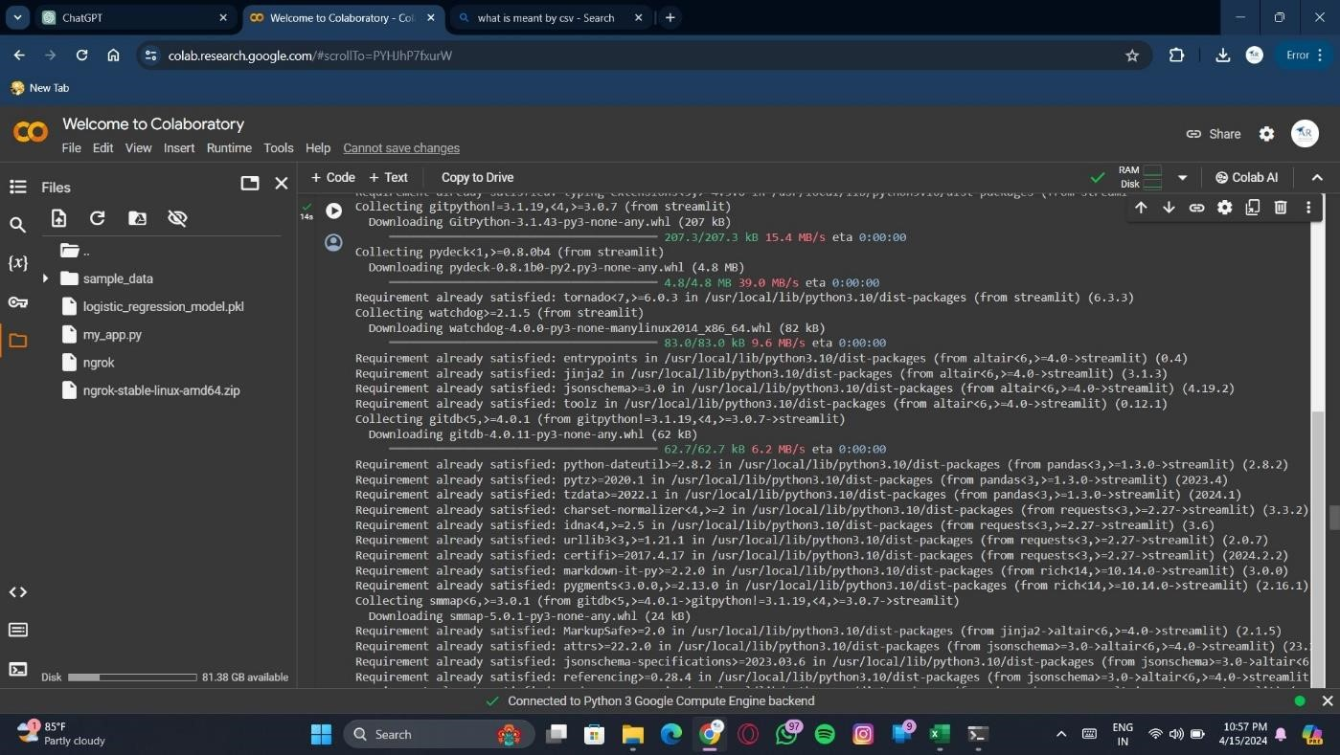

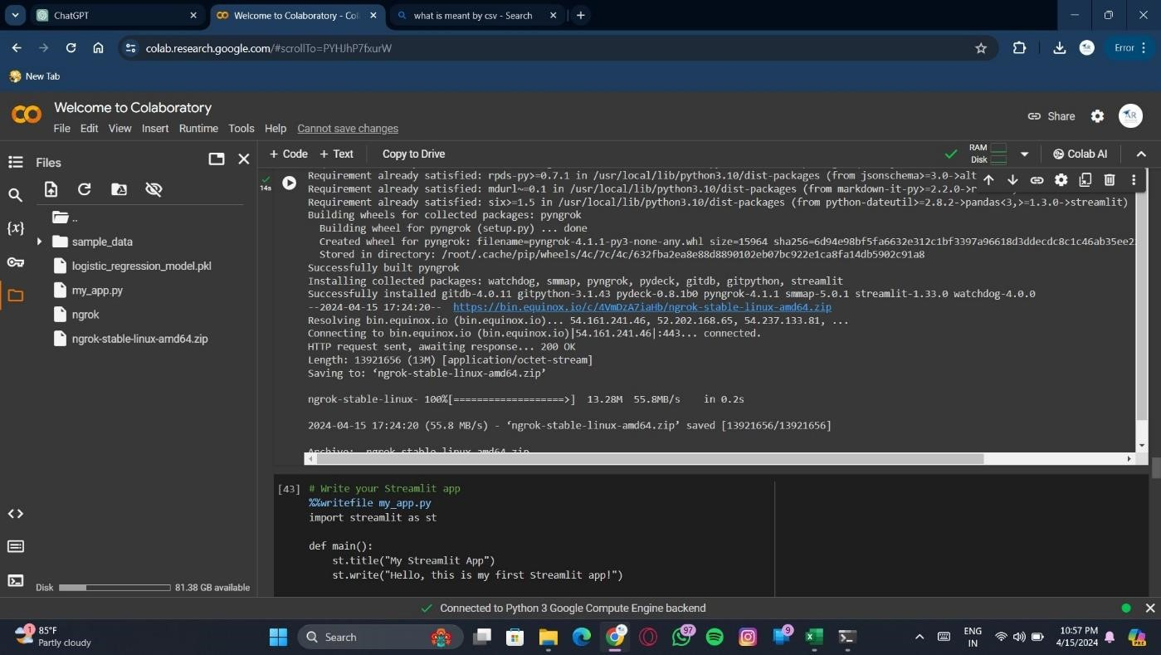

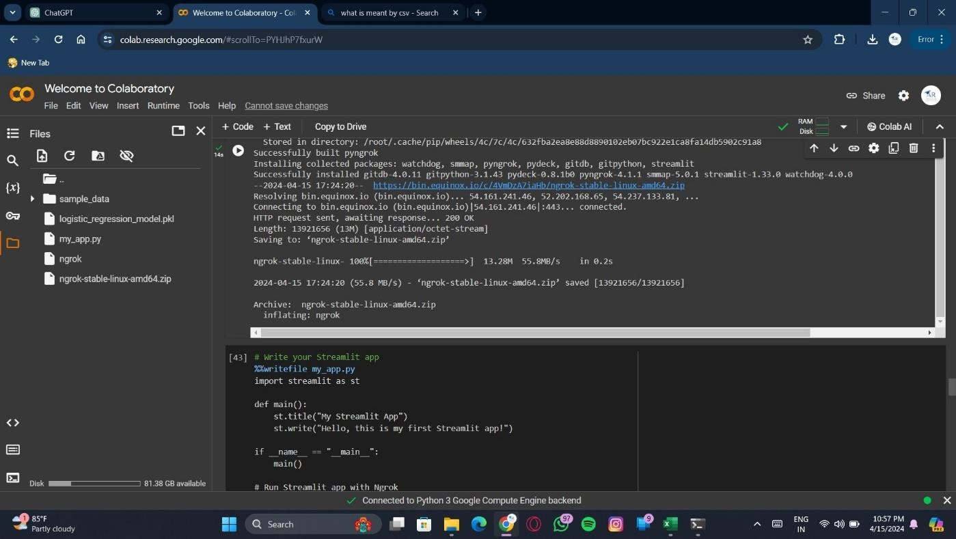

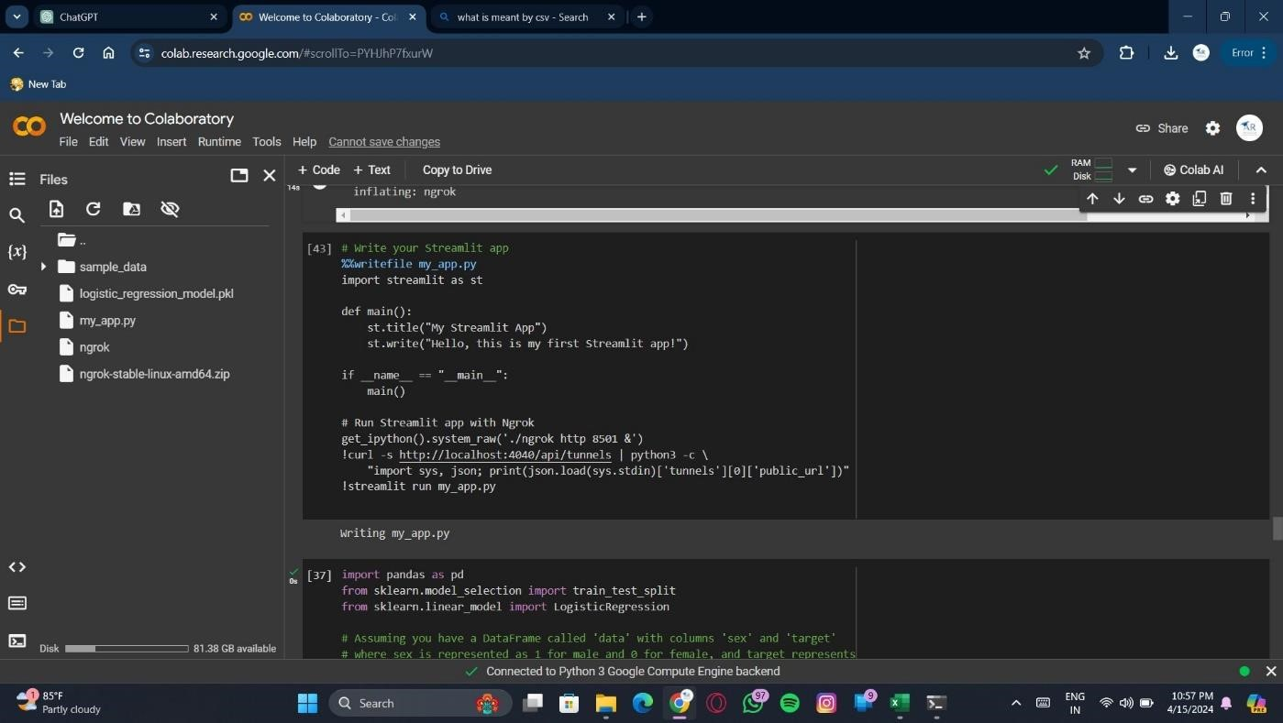

Probability of heart disease of each person

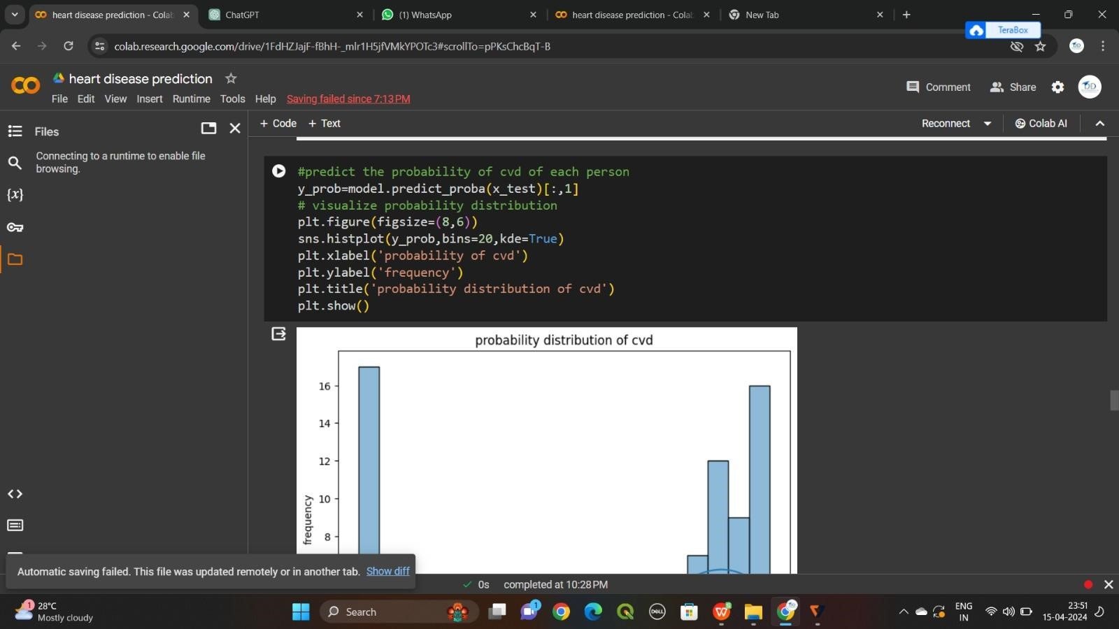

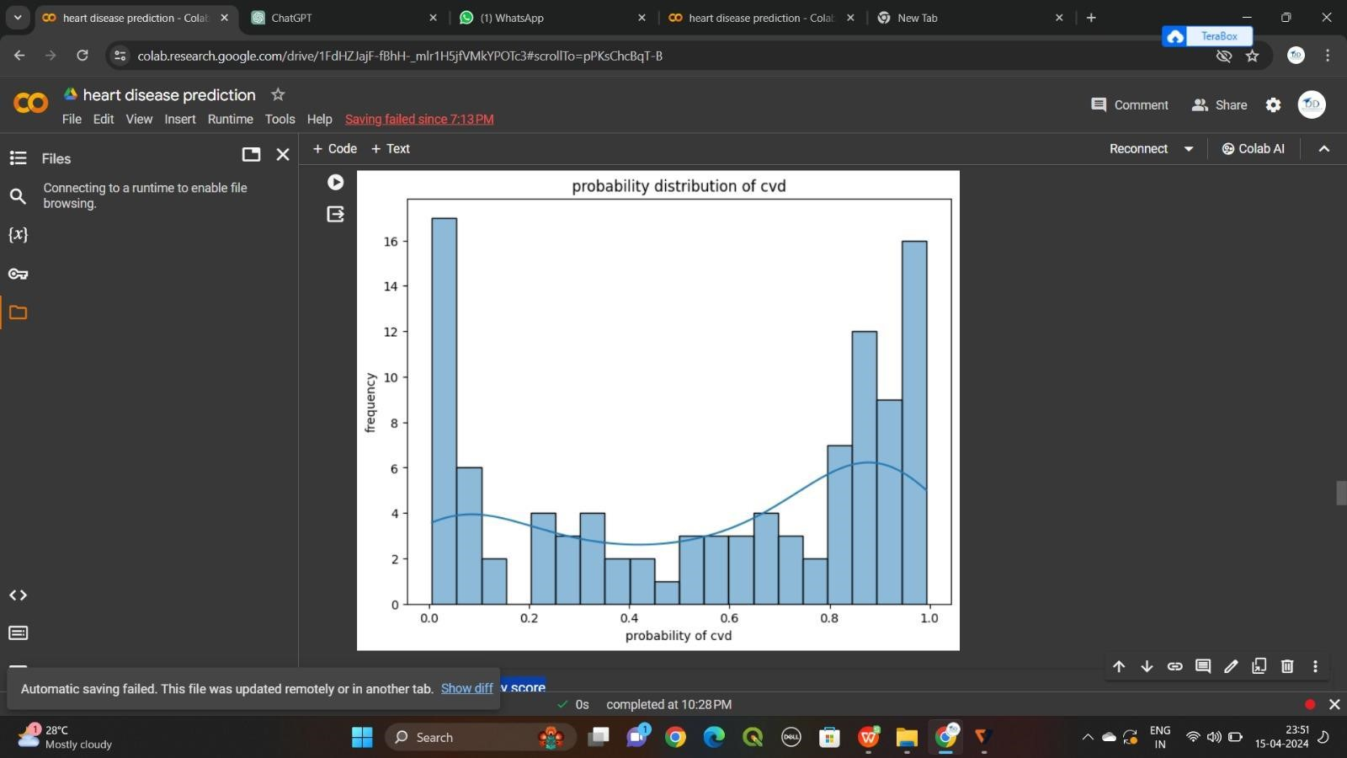

*LINK : https://youtu.be/XouSAUr8IVg*